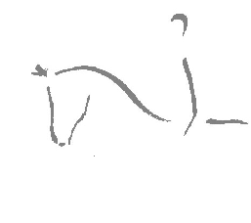VECTIS

EQUESTRIAN CLUB

AGM
Thursday 22nd November 2018
The Chequers Inn, Rookley
7.30 pm

AGENDA
- Apologies for absence
- Minutes of the last meeting
- Matters arising
- Chairman Report
- Treasurer Report
- Teams Report
- Election of the committee
Members due to stand for re-election are Di Andrews, Helen Woods & Beverley Snudden. Hilary Box has decided not to stand for re-election and will retire from the committee.
If anyone would like to put themselves forward for election, please kindly submit your names 14 days before the AGM
- Appointment of Auditor
- Any other business

Annual Awards

Please note that membership renewals are now due (£22 per annum) & can be paid at the AGM with a completed membership form

