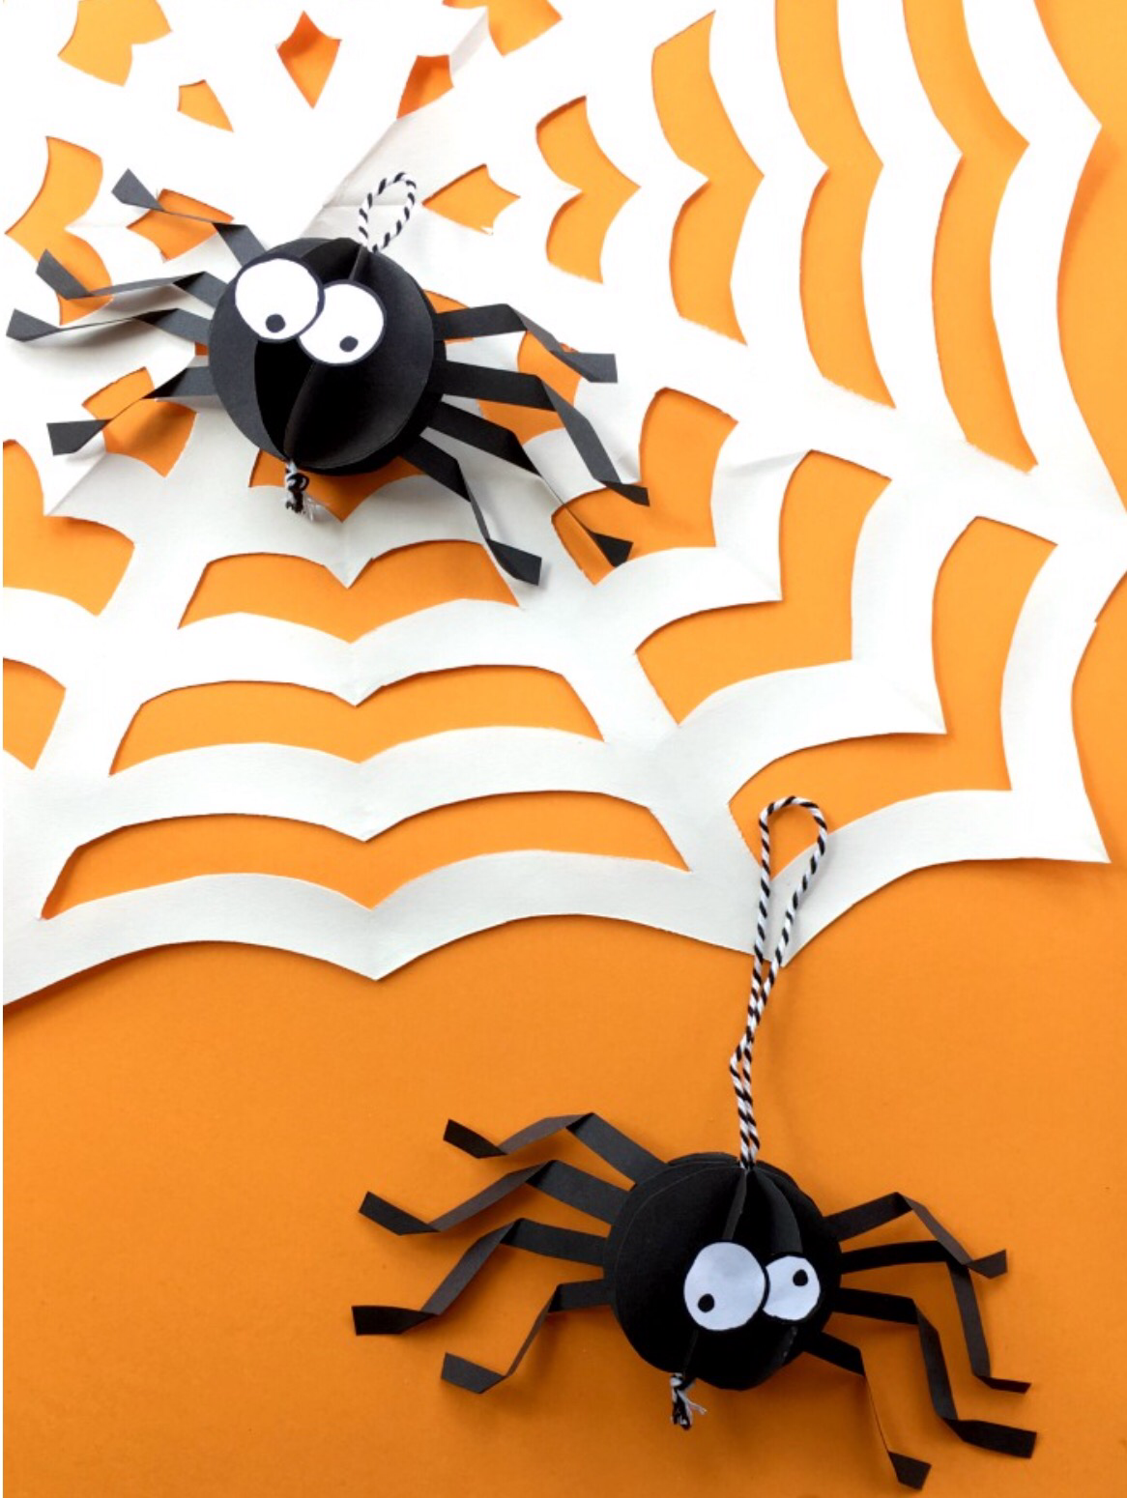
Spider ride-17th August 2018

Come and join us on our spider ride at Gatehouse farm,Ashey,PO33 5BJ .
Starts at 4pm and finish about 7pm .
£5 for the spider ride with a cake and a drink included.
Clear round jumping available for £2 per round.All money is raised for Vectis equestrian club. Hope you can join us.

Many thanks Phoebe xx
07834422304

